2025 Design-Your-Own Fellowship Application
Part 1: Introductory Information
The application should be completed by the candidate (the person applying to become a Fellow) and the Introductory Information section should contain the candidate's information.
The submitter profile (where one enters their name and email address to create a login to the Submittable platform) should also contain the candidate's information; if you need to update that profile, please check out this article.
For a candidate to work together with a Host Organization representative to populate the application, please use Submittable's collaboration function, as detailed in this article.
For questions in long answer format, please take note of the word count maximums. The usage of clear, concise, compelling language is welcomed, as are parenthetical citations and bullet points. Please use "enter" to delineate paragraph breaks.
First Name *
This should be the candidate's first name.

Last Name *
This should be the candidate's last name.

Phonetic Pronunciation of Name

Preferred Pronouns *
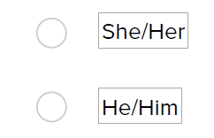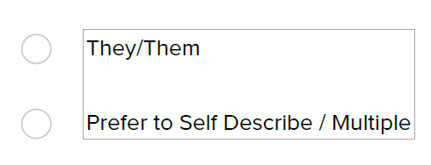
Please describe your preferred pronouns: *

Email *
email@example.com
This should be the candidate's email address and one that will be active through at least May 2025.

Phone *
This should be the candidate's phone number and one that will be active through at least May 2025.

Submission Name
Candidate's Full Name, Name of Host Organization *
This will be the unique identifier that accompanies your project.
For example, "Jay Doe, Local Community Services" if Jay Doe is the candidate (applicant to become a Fellow) and the prospective host organization for Jay's proposed Fellowship project is Local Community Services.
The answer to this question will be used as the unique identifier for each submission.

Host Organization City *

Host Organization State/U.S. Territory *

Law School *

Law School City *

Law School State/U.S. Territory *

Law School Graduation Date (Month and Year)*
Please list the anticipated month and year of the candidate's law school graduation or the actual one if the candidate has already graduated.

Provide a compelling one-sentence description of your proposed project and target population: *
Please begin the sentence with a verb.
For example: "Provide legal advocacy and outreach to low-income immigrants in Brooklyn, New York..."

Voluntary Identity Survey
Equal Justice Works strives to attract program participants who are diverse in many respects and, in this diversity, are able to understand and empower their clients and communities.
Completing this questionnaire is voluntary, but encouraged.
First generation college graduate
Immigrant or First-Generation American
LGBTQIA+
Low-income background
Person with a disability
Veteran or Active Duty Military
Race/Ethnicity
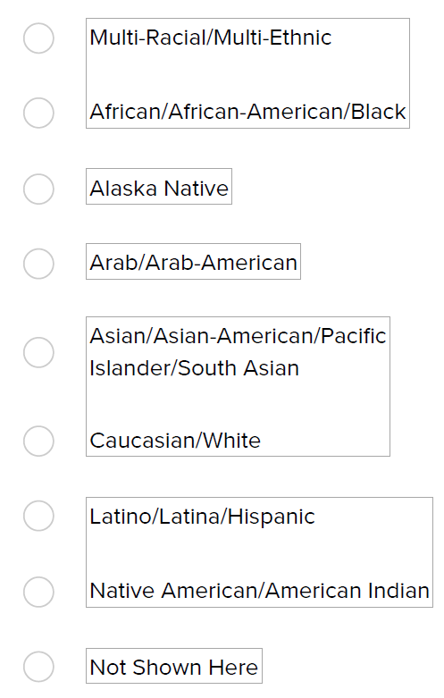

Please indicate your race/ethnicity - select as many as apply
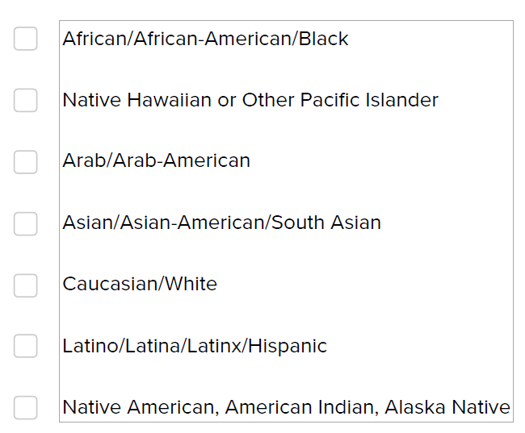
If your race/ethnicity is not shown in the list above, please describe here:
Gender Identity
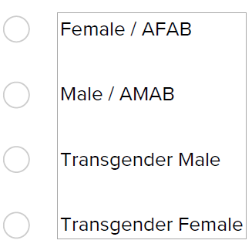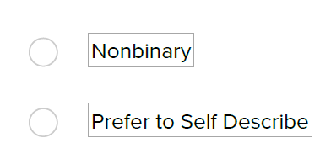
Please describe your gender:

Part 2: Host Organization Information
Host Organization Name *
The name of your nonprofit Host Organization should be entered exactly how you would like it to appear in Equal Justice Works communications and promotional materials. This can be either your host organization's trade name or the official, legal name, whichever the organization prefers.

Host Organization Website *
example.com

Host Organization Phone *

Executive Director's First Name *
If the Executive Director's contact information changes after you submit your application, please request to edit your application (as explained here) and update it.

Executive Director's Last Name *

Executive Director's Email *

Supervisor's First Name *
If the supervisor's contact information changes after you submit your application, please request to edit your application (as explained here) and update it.

Supervisor's Last Name *

Supervisor's Title *

Supervisor's Email Address *
email@example.com

Part 3: Project Description
Answers should be a collaborative effort between the prospective host organization and the candidate. Please use Submittable's collaboration function, as detailed in this article.
Please select the most relevant subject area classification for your project. *

Please select a secondary issue area classification for your project. *

Does the proposed project include a racial justice component? *
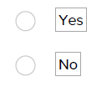

Is the proposed project national in scope? *
Is the service area of your project different from the host organization location above? *
Location(s) of the clients or targeted populations of the project: *
Please select from the below how you anticipate working: *
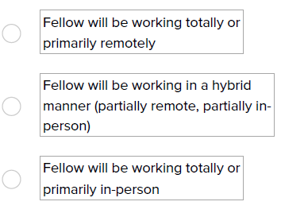
If working totally or primarily remotely, will the Fellow be in a different city from the host organization location listed above? *
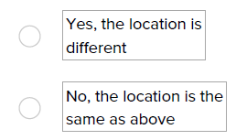
Please note the location where the Fellow will be working:
City *

State/U.S. Territory *

Statement of need *
Limit: 400 words
Provide a concise statement (no more than 400 words, recommended minimum of 150 words) of the problem(s) your project seeks to address and the community to be served. The needs statement establishes the focus and rationale for the project, and should include elements such as a description of the target population to be served (e.g. number of people affected, characteristics, geographic service area), the availability of existing services, urgency/timeliness, and potential impact, etc.

Project goals *
Describe the overall project goals, including the strategies you intend to employ and the major short-term and longer-term outcomes anticipated, such as project sustainability beyond the Fellowship term. Goals should be specific, measurable, achievable, realistic/relevant and time-bound. If applicable, please describe how your project will impact racial justice and equity. Please limit to no more than 400 words (recommended minimum of 150 words).

Timeline
Utilizing a two-year timeline, describe the major project milestones (actions or activities completed towards meeting goals) that will be accomplished, in six month increments, in order to achieve the overall project goals. Bullet points are welcomed.
0 - 6 Months: *
Limit: 1000 characters

6 - 12 Months: *
Limit: 1000 characters

12 - 18 Months: *
Limit: 1000 characters

18 - 24 Months *
Limit: 1000 characters

Please describe how the proposed project is distinguishable from, or complementary to, any existing services for your target communities or geographic area: *
Limit: 400 words
Please note if you have already discussed collaborating with other providers/organizers. Please limit to no more than 400 words (recommended minimum of 150 words).

Is the project a Medical-Legal Partnership (MLP) ? *
Name of medical/health care partner organization: *

Has the medical/health care partner confirmed their participation in the MLP if the Fellowship is awarded? *
Please describe: *

Has the medical/health care partner confirmed their participation in the MLP if the Fellowship is awarded? *
Please describe: *

Is the Fellow creating a new MLP or expanding an existing MLP? *
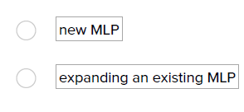
Who currently runs the MLP? *

Is that person the Fellow's proposed supervisor? *

Potential Sponsor Involvement and Pro Bono Opportunities
Equal Justice Works Fellowships are sponsored (funded) by law firms, corporations, individuals and foundations. Most Fellowship sponsors are interested in being involved with the Fellows they select to fund. Many sponsors choose candidates to interview and select a Fellow based on potential opportunities for involvement.
Please describe below the Host Organization’s existing pro bono program, if any. *
Limit: 250 words
Please limit to no more than 250 words (recommended minimum of 150 words).

Please describe below the ways in which your project could involve a sponsor, including attorney and non-attorney staff (e.g., staffing a clinic, serving as litigation co-counsel, conducting research, providing data analysis support, etc.). Please consider what opportunities may be available for in-person volunteers and those available for remote volunteers. *
Limit: 300 words
Because sponsors vary widely in terms of the engagement they seek, we suggest presenting a "menu" of options. Please limit to no more than 300 words (recommended minimum of 150 words).

Please describe the candidate's experience working alongside or leading pro bono volunteer attorneys and/or other volunteers, if any. *
Limit: 250 words
Please limit to no more than 250 words (recommended minimum of 150 words).

Do you anticipate your project would provide virtual pro bono opportunities? *

Does the proposed project present legal pro bono opportunities for volunteers based in multiple states? *
Do you anticipate the proposed project offering volunteer opportunities that do not require a volunteer to have bar licensure?*
Part 4: Candidate Information
Part 4 should be completed by the candidate and reviewed by the prospective host organization.
Anticipated/Current Bar Exam Jurisdiction *

If your anticipated or current bar exam jurisdiction does not match your project's service area, please explain.

Have you applied for an Equal Justice Works Fellowship previously? *
Are you a current or former legal post-graduate Equal Justice Works Fellow? *
Have you ever participated in any of the following Equal Justice Works programs? *
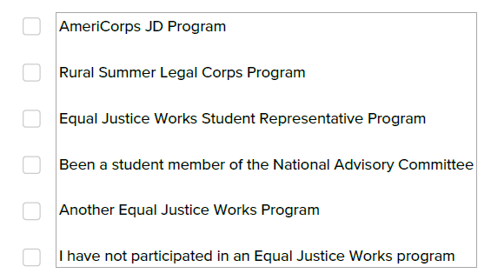

Have you applied, or do you intend to apply, to another Fellowship program besides Equal Justice Works? *
Please select the other fellowship programs you have applied to or intend to apply to:
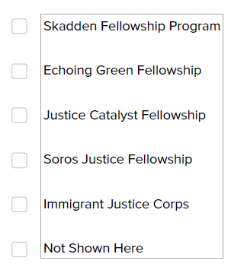
To which other program have/will you apply? *
Have you applied, or do you intend to apply, to an upcoming judicial clerkship besides Equal Justice Works? *
Please provide the month and year the clerkship will begin *

Please list the languages you know and your level of proficiency

Personal Statement *
Limit: 500 words
Briefly describe, in the first person, how your personal background, experiences, or unique qualifications best suit you for this Fellowship project. Explain your connection to the community with which you will work. Please limit to no more than 500 words.

Part 5: Host Organization Background
Part 5 should be completed by the prospective host organization with input from the candidate. To work together to populate the application, please use Submittable's collaboration function, as detailed in this article.
Please describe how the project was developed and how it relates to the overall mission and current strategies of the organization. Include a description of how the proposed project is distinct from the work of a general staff attorney or any previous Fellow at the host organization. *
Limit: 400 words
For example, a project might take a new approach to addressing an issue affecting the organization's target population or replicate a model that has proven successful in another community. Please limit to no more than 400 words (recommended minimum of 150 words).

Please explain the candidate's experience with your organization, including what measures your organization has taken to familiarize your candidate with their proposed project supervisor, the culture of the office and mission of the organization, and the salary and benefits they will be provided. If candidate has not interned or volunteered at the host organization, please affirm that the candidate has visited host organization's office and met in person with proposed supervisor and other members of the staff. If an in-person visit or meeting was not possible, please explain what alternative meetings took place. *
Limit: 300 words
Please limit to no more than 300 words (recommended minimum of 150 words).

Has the organization hosted Equal Justice Works Fellows in the past? *
Were any former Fellows hired as full-time staff with the organization after their Fellowships ended?*
Please explain: *

Were the above Fellowship projects sustained at the host organization after the Fellowships? *
Please explain: *

State the number of total staff at the organization: *

How many of your staff are attorneys? *

Fellowship host organizations are required to provide thorough orientation, training, support, and legal supervision throughout the term of the Fellowship. Please answer the following questions related to support:
Is the Fellow's direct supervisor a full-time attorney? *
Please confirm by checking each box that the Fellow's supervisor:
Works in the same office where the Fellow will work
Will serve as the subject matter supervisor for the Fellow
Has been involved in the design of this Fellowship project and application
Has experience managing staff
If any of the above are not selected, please explain:

The Fellow's structured and supportive relationship with their supervisor is a key element of Fellowship success. Please provide a brief description of the supervisor's experiences related to the proposed Fellowship project, including subject matter expertise and experience managing new attorneys. *
Limit: 300 words
Please limit to no more than 300 words (recommended minimum of 150 words).

Briefly describe the anticipated training and supervision plan for the Fellow, i.e., onboarding plan, frequency of check-ins, skills development, progress tracking, work product review, etc. Please also describe your organizational performance management structure (e.g., performance reviews) and HR management (e.g., HR manager). *
Limit: 250 words
Please limit to no more than 250 words (recommended minimum of 150 words).

Please outline what steps will be taken to provide adequate supervision for the Fellow should the primary supervisor no longer be available. *
Limit: 400 words
Please limit to no more than 400 words (recommended minimum of 150 words).

Please confirm by checking the applicable box below that the Fellow will be at minimum provided with the following: *
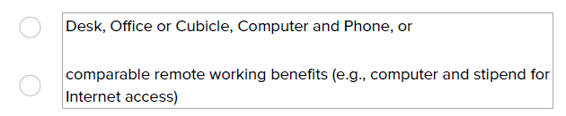

Describe the technology and office or work from home resources that will be available to the Fellow. *
Limit: 400 words
Please limit to no more than 400 words (recommended minimum of 150 words).

Part 6: Important Documents & Information
Upload Your Resume Here: *
Please limit your resume to two pages (if printed, one page double-sided) unless additional information is necessary. Please do not include class rank or GPA in your resume or other application materials. Please save and upload it in PDF format.

Upload Certification Form Here: *
Please visit this website to access and download the Certification Form. It contains hyperlinks to the sample Memoranda of Agreement (Fellow-Equal Justice Works and Host Organization Equal Justice Works). After you and the Host Organization have completed it, please save it in PDF format and upload it here.

Reference Information
The reference must be a professional or academic reference and cannot be from your proposed host organization. It must be a different person than either of your letter of recommendation writers. Different individuals from the same organization may serve as letter recommenders and references, respectively.
Name of Reference *
First Name
Last Name

Reference's Email Address *
email@example.com

Reference's Phone Number *

Organization Name *

City *

State/U.S. Territory *

Time period in which the work, study or volunteer service was performed *

Letters of Recommendation
Two letters of recommendation in PDF format are required.
Letters of recommendation may come from people you know from your legal, volunteer, job, or academic experience, and should come from people who can speak to your work product. If you have previously worked at your host organization, it is acceptable for one letter to come from a person at the host organization.
Please ask recommenders to address the letters to the “Fellowship Committee” and submit letters of recommendation on their organizational letterhead if possible. Each letter should include the recommender's phone number and email address.
Both letters must be uploaded in this application in time to click to submit no later than the application deadline. Equal Justice Works does not accept letters by email.
Letter of Recommendation #1 *

Letter of Recommendation #2 *

May Equal Justice Works share information about the status of your application with your law school? Application status information may include, for example, whether your application is under consideration by a sponsor, whether you've been invited to interview, or similar. As the applicant, this information is always available to you directly as well by emailing the Equal Justice Works team via the messaging function in Submittable. *
